**PROJECT**

**2nd Increment Report**

**on**

**“CLASS SCHEDULER”**

**By**

**Sumanth Koushik Kalli**

**Alekhya Boyapati**

**Savya Pathuri**

**Importing Existing Services:**

The existing services in this increment are implemented using HTML language, JavaScript, cascading style sheets (CSS) and PHP in making a good user interface. Also, we have tried to make part of the scheduling algorithm as SOAP web service. We have completed the installation of Database into our project. In the exercise of finding out the best scheduling algorithm, we have found that scheduling algorithms are best implemented using genetic algorithms and we are trying to learn it to use in our project. In the next increments, we will continue to use the services and complete the algorithm.

**Detail Design of Services:**

In this web application, we have created a database which will be storing details of the courses such as Course ID and course name, Faculty name and Faculty ID, day of the class and timings available on each day. We have also got part of our scheduling algorithm which takes the input from the database and tells on which day a particular professor’s class should be on.

**Sequence Diagram:**

The below diagram shows the sequence diagram of our application.

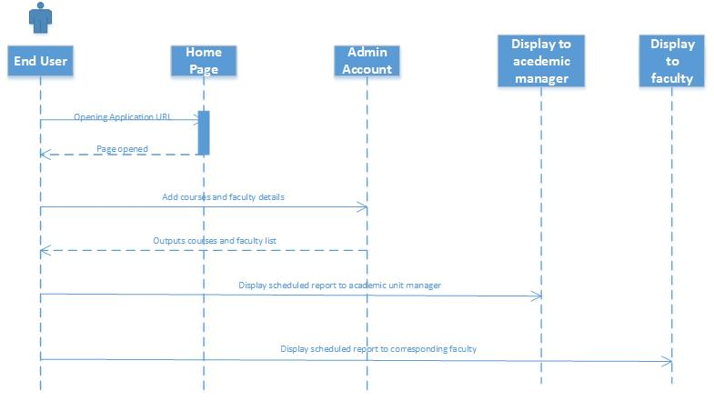

**System Architecture Diagram:**

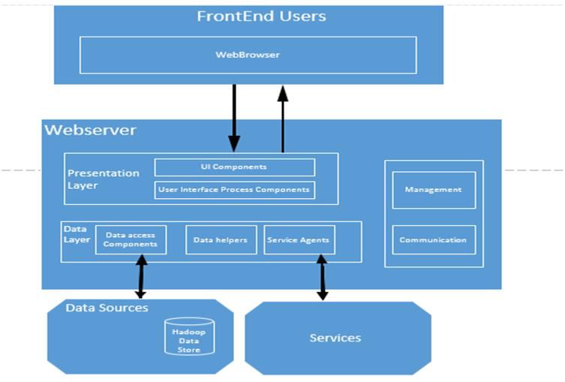

**Implementation**

**Implementation of services:** We created home screen for our project and also the chance to change the password for the users. The courses and the names of professors taking the courses will be entered manually and the classes will be scheduled systematically.

**Implementation of user interface:** Here we implemented the user interface using the HTML language and Cascading style sheets. The initial home screen is developed in this project for this increment. Further modules will be added in upcoming increments.

**Report:** In our project “CLASS SCHEDULER” we have developed a part of front end and back end in this increment using HTML, JavaScript, CSS for web development and created a database to store our details. Also, using C# and SOAP we have developed a web service that schedules on which particular day a particular professor’s class will be.

We also collected additional data regarding the courses offered in Fall 2013 Graduate Computer Science Degree and the names of the professors for that particular courses from the UMKC website along with their research work details.

**Implementation Status Report**

**Work Completed:**

* **Description:** In the second increment, we completed installation of the database and a part of the scheduling algorithm. Also, we have collected data regarding the professor’s research work to schedule on which particular day his/her class should be on.
* **Responsibility:**

**Algorithm:** The scheduling algorithm and the logic behind it has come out through everybody’s thought process and also the implementation of this logic is done by Sumanth, Alekhya and Savya.

**Database Installation:** It has been done by Sumanth Koushik and Alekhya.

**Collection of Static Data:** The professor’s research details are details are collected by

Savya and organized and analyzed by Alekhya and Sumanth.

**Documentation:** Documentation for the 2nd increment has been prepared by Alekhya

Boyapati, Sumanth Koushik Kalli and Savya Paturi.

* **Time Taken:** Individually, we have spent 65 hours each towards this increment.
* **Contributions:**

**Sumanth:** Algorithm building, database installation and documentation, data analyzing.

**Alekhya:** Algorithm building, database installation, and documentation.

**Savya:** Collecting data about professor’s research work and algorithm building and documentation.

**Work to be completed:**

* **Description:** In further increments, we are moving forward to complete the scheduling algorithm, building schedule interface for display to faculty, adding send email to faculty feature to the Manager’s account.
* **Responsibility:**

Completing this scheduling algorithm will be shared equally amongst the three team members. Alekhya is mainly involved in learning the new genetic algorithm and adapting it to our project. Sumanth is involved in algorithm completion and website updation and Savya is involved in carving a good interface for the schedule interface.

* **Time Taken:** We estimate that we require around 90 hours each for an increment.

**Issues/Concerns:**

As in the previous increment, we haven’t had any major technical issue. But, we are concerned about learning genetic algorithm which is used to make these kinds of scheduling algorithms.

**Deployment:**

**Scrum Do Link:** https://www.scrumdo.com/projects/project/class-scheduler/stories/#

**Github Link:** https://github.com/sumanth2109/AdvancedSoftwareEngineering/tree/master/Class%20Scheduler